Group No: | 45
Group Members (Student IDs): | Valiant Tai Zi Pin (20705238)  Yang Shun Xi (20706107)  Min Pyae Phyo (20710858)  Sivanesan Jeevananthan (20715651)

YOUR Group Details:

Justification of YOUR Circuitry Diagram Design:

Jump Conditions
The design of the new CPU Jump Design improves both clarity and efficiency. In this new CPU Jump Design, the jump logic and control flow have been reorganised to make conditional execution cleaner and easier to understand. In the original CPU jump design, multiple AND gates were connected directly to the instruction[15] bit at various stages, as shown in Figure 1.

In the new CPU jump design, the individual jump conditions (ld1, ld2, and ld3) are first combined, and the instruction[15] check is applied only once at the end to generate the final RealJump signal, as shown in Figure 2. A NOR gate is also used to replace the separate NOT and OR gates previously used for the Zr and Ng signals. Lastly, an Or3Way gate is used to simplify the three OR gates included in the original CPU design. Overall, the new CPU jump design reduces the total number of gates used by 5, compared to the original design.

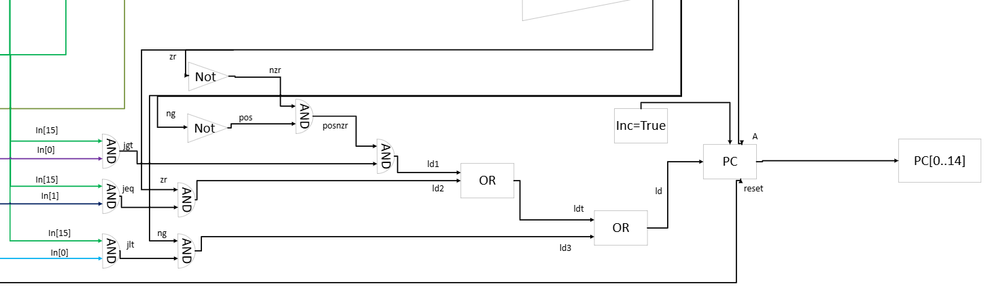
Figure 1 Illustrates the Original CPU Jump Design

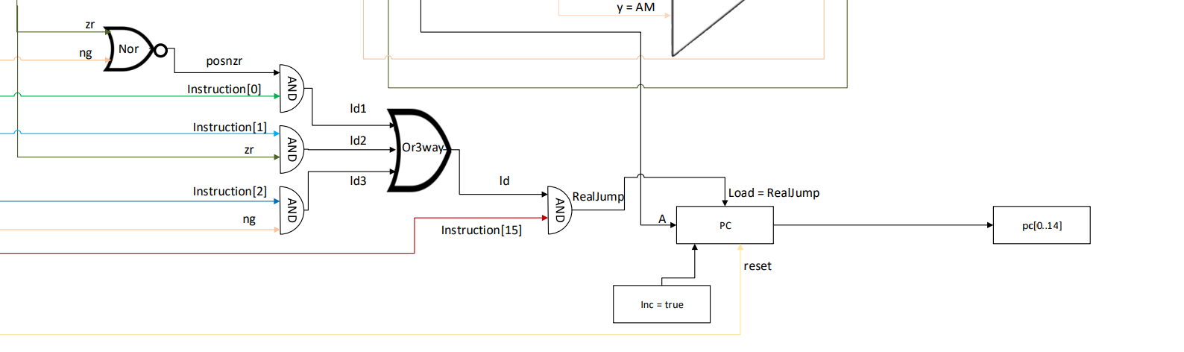
Figure 2 Illustrates the new CPU Jump Design

A instructions/C instructions
Furthermore, the new CPU A/C Instruction Design also uses a dmux gate for determining when to load C instructions or A instructions to improve readability and reduce complexity. In the original design, it uses a Not gate to invert the Instruction[15] to use it for the A register shown in Figure 3. In the new CPU A/C Instruction Design it used a Dmux gate to cleanly differentiate between A or C instruction by replacing the Not gate for Instruction[15] shown in Figure 4 and improving readability and reducing complexity.

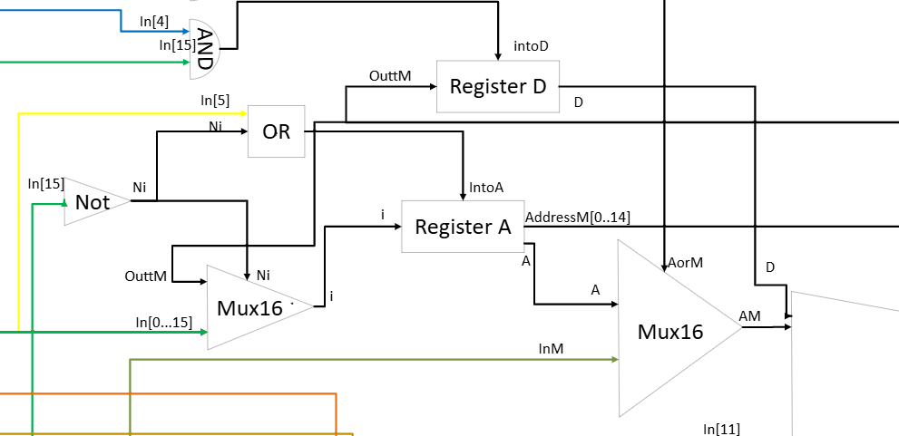
Figure 3 Illustrates the Original CPU A/C Instruction Design

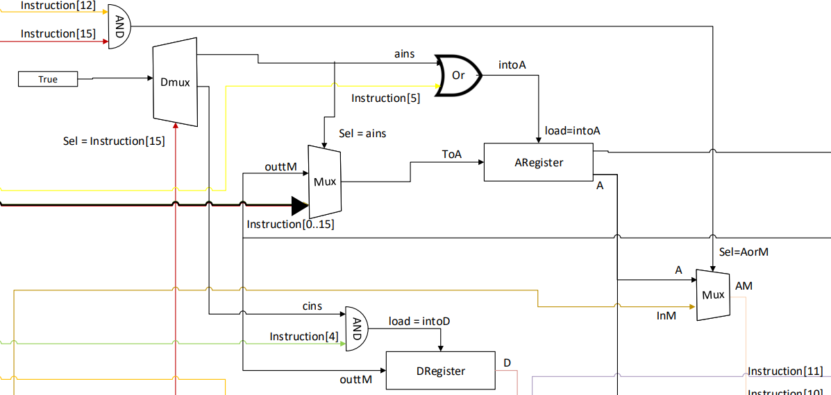
Figure 4 Illustrates the New CPU A/C Instruction Design

Table1
The differences in speed in the Original CPU Design with the New CPU Design
 | Fast Speed | Normal Speed
Original CPU Design | Average=11.72 Second | Average=47.85 Second
  Test No | Speed
  1 | 11.83
  2 | 11.91
  3 | 11.43
  Test No | Speed
  1 | 47.89
  2 | 47.94
  3 | 47.74
New CPU Design | Average=11.18 Second | Average=47.53 Second
  Test No | Speed
  1 | 11.18
  2 | 11.10
  3 | 11.28
  Test No | Speed
  1 | 47.60
  2 | 47.45
  3 | 47.56

In conclusion, the new CPU Design is faster than the Original CPU Design because this is due to the fact the new CPU Design reduced 5 gates in the Jump Condition.

